

Producing Climate Change Scenarios and Risk Assessments for Africa: Gambia

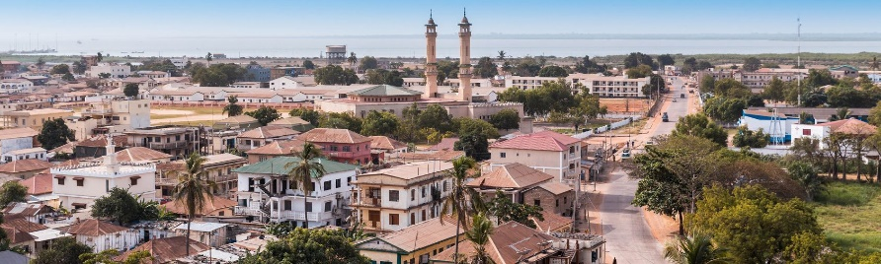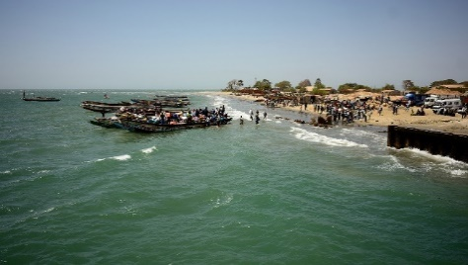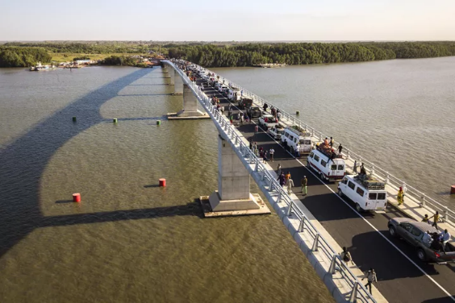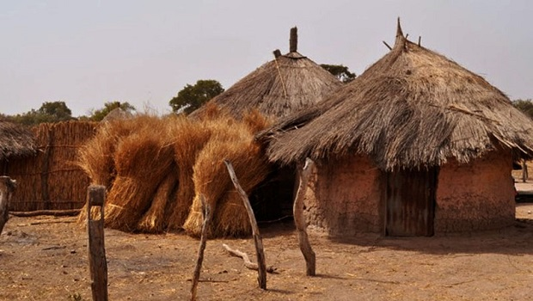

L2: GIS USER REQUIREMENT SPECIFICATIONS
Consortium | ARIA Technologies, ACTERRA, AGRER
Authors | Genesis T. Yengoh, Alex Resovsky, Claude Derognat, Landing Bojang, Blandine Lheveder
Contact person | Alex Resovsky (aresovsky@aria.fr)
Date | September 29th, 2021

Introduction
The Gambia’s natural hazards profile is characterized by exposure to multiple hazards including hydrological (i.e. floods), climatological (droughts), meteorological (severe storms), and biological (i.e. locust invasions, epidemics) (see Figure 1 and Table 1). While hydrological hazards occur frequently (seasonal or annual), the occurrence of biological hazards is relatively low. However, given the high population density in The Gambia’s urban areas (especially the Kombos and Banjul), the increasing number of disenfranchised populations – especially amongst the poorly educated and the rural-urban migrants – and the overstretched capacity of social services and physical infrastructures, even mild environmental disasters could have serious impacts. Some of the impacts identified by the National Disaster Management Authority include: food insecurity, rural-urban migration, increase in the prevalence of infectious diseases, etc. Long-term impacts include poverty, unemployment, and limited access to land. The 2013 National Contingency Plan for The Gambia identified a more comprehensive list of impacts of disasters, their frequency, and vulnerable locations in the period from the 1940s to 2010 (Table 1).
These impacts are forecast to increase in severity and scale as the occurrence and severity of climatic hazards such as drought, floods and damaging winds is expected to augment with climate change and cause significant socio-economic and environmental losses. Rapid unplanned urbanization (especially in the Kombos), unsustainable water management practices and uncoordinated land use planning are the main underlying risk drivers in the Gambia. Investing in disaster preparedness and prevention is a building block of The Gambia’s national security and economic development. Climate change is expected to increase the occurrence and intensity of natural hazards, epidemics and pest. Living to the ambition of the Gambia’s 2030 Vision and achieving the Government’s National Development Plan as well as The Gambia’s Sustainable Development Goals (SDGs) targets would require targeted investment in building capacities in key sectors to integrate disaster and climate risk reduction measures at national and local levels.
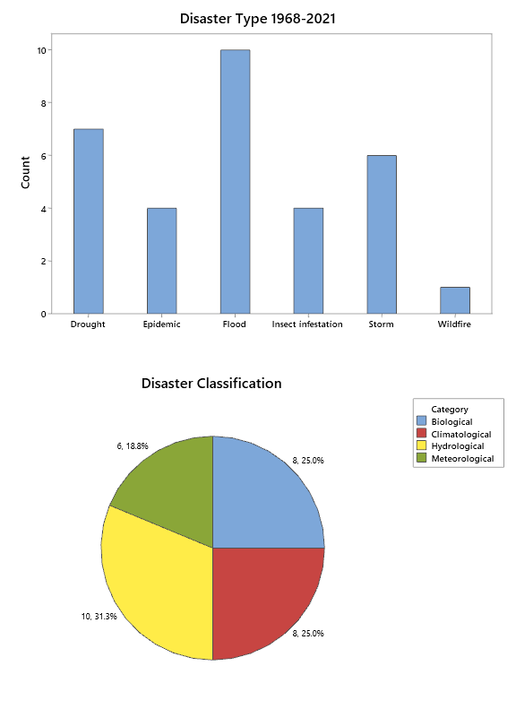
Figure 1. The frequency of occurrence of major natural disasters in the Gambia (Data source: EM-DAT, 2021)
Two main factors explain The Gambia’s vulnerability to environmental disaster: i) its geographical location, and (ii) its level of development. Geographically, the country sits in a region with a harsh climate², which makes it difficult to undertake the main economic activity that supports a vast majority of its rural population and contributes substantially to the country’s Gross Domestic Product (agriculture). The geography of the Gambia is also heavily influenced by and reliant on its largest hydrological feature, the River Gambia. The country’s vulnerability to environmental disasters is a result of its stage in economic development. The Gambia is still at a very early stage in economic development. It is indeed one of the poorest countries in the sub-region. The last two years have not been favorable for economic performance, decreasing the potential for the country to address its vulnerabilities to global environmental changes and disasters. One of the main challenges in the past two years has been the devastating effects of the Covid-19 pandemic to two key economic sectors of the Gambia – tourism and remittances. The decline in remittances and tourism receipts widened the current account deficit to 8.6% of GDP from 5.3% in 2019. Notwithstanding the negative effects of the Covid-19 pandemic on the country, positive economic trends are expected in the short-term in the Gambia. For example, the real GDP is projected to pick up gradually—growing by 3.2% in 2021 and 5.1% in 2022. Inflation is projected to decline marginally to 5.9% in 2021 and 5.7% the following year. The fiscal deficit is projected to narrow to 3.2% of GDP in 2021 and 2.3% in 2022, while the current account deficit will widen to 10.4% of GDP in 2021 and 10.1% in 2022.
Table 1. History of natural disasters in the Gambia
Type of Disaster | Period | Nature/Impact | Vulnerable areas
Floods | 1948, 1954,1955, 1956, 1998, 1999, 2002, 2003, 2004, 2005, 2006, 2007, 2009, 2010 | - Destruction of houses and household items – people displaced  - Agricultural damage (crops and livestock), in all the rural districts  - Loss of lives  - Transport and ferry facilities interrupted  - Blockage of waterways and drainage systems  - Inundation of settlements; | - High-density urban slums Greater Banjul Area (Ebo Town); - Settlements on wetlands (Kotu Quarry)  - Flood plains of Kaur and Kuntaur - Lowland rice fields of Central and Upper River Region (north and south)  - North Bank Region
Forest fires | Fire season (October –May) | 185,803 hectares of burnt forests 169 forest fires in 2004  - 40.25% of total forest cover burnt  - 70% of community forests and 95% of forest parks damaged  - animals killed | - Lower River Region
Disease outbreak | 2008, 2009  2006, 2007 | - Cholera outbreaks linked to floods and resulted in deaths  - Cholera outbreaks from attending religious gatherings in neighbouring Senegal | - Kanifing Municipality
The impacts of hydrological, meteorological and climatological hazards are especially important for the Gambia as a great deal of its economy relies on favourable environmental circumstances to strive. For example, 75% of Gambia’s population depend on farming, so the country is highly vulnerable to the climatic effects of erratic rainfall and severe heat stress. Farmers complain that their wells are now drying out too early in the season. Due to an overreliance on erratic rainfall, limited irrigation infrastructure and deteriorating soil quality, productivity in these sectors remains low. The economy remains dependent on a dominant tourism sector that is sensitive to domestic and regional political instability and the external economic environment. In addition, coastal erosion caused by climate change poses a serious threat to the viability of the sector, as beaches are The Gambia’s main tourist attraction. In the absence of mechanisms to mitigate shocks and strengthen resilience, these vulnerabilities increase uncertainty and reduce the return to investments for firms. For households, limited protection against shocks arises from the lack of social safety nets and increases the risk of falling into poverty or remaining in chronic poverty.
The lack of information management systems hinders disaster risk management in the Gambia. Even though data collection and mapping capacities exist in the country, the capacity is limited. One key aspect of the use of data in disaster risk management and the reduction of vulnerability is the fact that risk information is not accessible to decision makers at national and local level and even less to the population. An integrated disaster risk information system, centralizing hazard, exposure and vulnerability information produced by different stakeholders with clear data sharing protocols, can go a long way in addressing this gap. This will especially be useful as risk information is accessible free of charge to public and private sector stakeholders. Training on the capacity to interpret such data and the application of risk information in planning and budgeting can go a long way in reducing vulnerability to environmental disasters. Such training would serve to empower institutions, communities and people to protect their lives, environments and livelihoods.

The role of Early Warning Systems in the Gambia
Early warning is a major element of disaster risk reduction. It prevents loss of life and reduces the economic and material impact of disasters. An Early Warning System (EWS) is an adaptive measure for climate change, using integrated communication systems to help communities prepare for hazardous climate-related events. One key focus area of Gambia’s Disaster Management Strategy is that of “improving Early Warning Systems.” The logic of intervention for this focus area consists of: (i) continuously monitoring identified hazards, vulnerabilities and threats; (ii) development of standard risk and monitoring instruments and undertaking risk and hazard mapping; (iii) fostering an understanding of disaster management; (iv) implementing mechanisms for information dissemination and advocacy; and improving the flow of information and data on risk among government departments and key partners.
In the Gambia an EWS responds directly to the priorities and actions identified in the NAPA of Gambia. The NAPA articulates the need for securing, transferring and installing critical technologies, as well as developing the necessary systems for climate change-related information to permeate into decision-making processes. The technologies required to achieve these aims will increase the capacity of the national early warning network to forewarn and rapidly respond to extreme climate events. In the same light, the EWS is consistent with the Gambia’s National Development Plan (NDP), 2018–2021 within which disaster risk management is identified as one of seven “critical enablers” that will facilitate the achievement of the nation's strategic priorities that are focused on delivering good governance and accountability, social cohesion, national reconsolidation and revitalization, and transforming the national economy. Finally, an EWS also responds to one of the key international actions on disaster risk reduction – The Sendai Framework for Disaster Risk Reduction 2015–2030. This framework puts emphasis on managing risk instead of disasters through four key priorities for action: (i) understanding disaster risk, (ii) strengthening disaster risk governance to manage disaster risk, (iii) investing in disaster risk reduction for resilience, and (iv) enhancing disaster preparedness for effective response and to “Build Back Better” in recovery, rehabilitation and reconstruction.

Implementing a comprehensive and people-centered EWS
One of the findings in a study commissioned by the United Nations Office for Disaster Risk Reduction (UNDRR), on tsunami early warnings in Indonesia highlighted the importance of not becoming too dependent on technology and the importance of building on community and indigenous knowledge. Indeed, the community should be the focus and the main subject of tsunami disaster risk reduction efforts. In the absence of community engagement to raise awareness and preparedness, over-reliance on technological solutions has the potential to create a false sense of security which contributes to complacency. Technological solutions need to be embedded in strong community engagement and outreach activities. The last row of Table 8 is included to address the potential for over-reliance in technology – the need to ensure a people-focused approach to the development and deployment of an EWS in The Gambia.

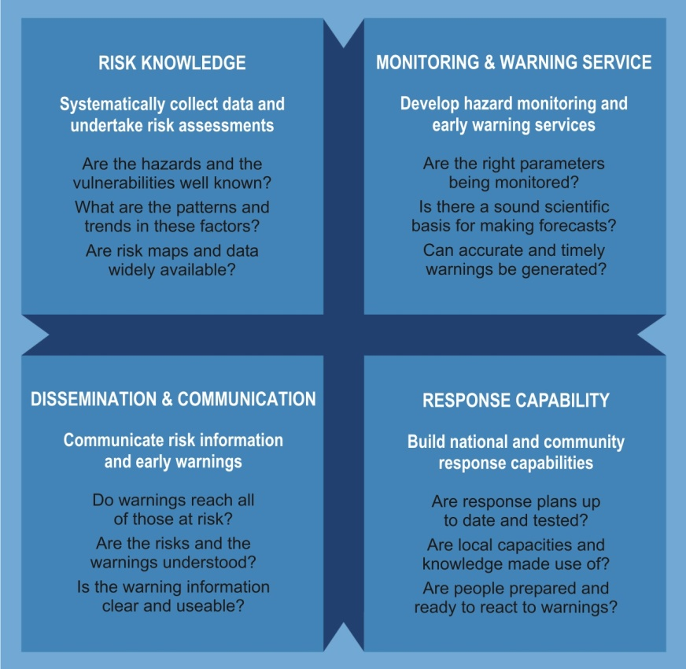
Figure 2. Four Elements of People-centered Early Warning Systems
Figure 2 shows the four inter-related elements for a complete and effective EWS, comprising knowledge of risks and hazards (the capability of the people); the monitoring and warning service (the EWS platform); dissemination and communication (reaching key stakeholders with risk information; and response capability (understanding the scale of risk and taking relevant action). The United Nations Office for Disaster Risk Reduction identifies five key contributors to boosting the efficiency of EWSs:
- Institutional and legal capacity development: Gaps or inefficiencies in legal, institutional and coordination frameworks can hinder the operation of EWS or lead to confusion. The report offers suggestions to overcome this challenge.
- Technology deployment: Thanks to technology advancements, all the elements of an EWS are easily implemented from monitoring, forecasting, and warning dissemination. Yet, many developing countries still lack the necessary technology infrastructure and capabilities.
- Community outreach and community-based solutions: Local and political context also plays a crucial role in implementing an EWS, while engaging and empowering the community also presents some linguistic and cultural barriers. Hence, to overcome these challenges, content and presentation of warnings needs to be customized or contextualize to fit the area where the EWS will be used.
- Private sector engagement: The private sector is the ideal advocate for resilient thinking because of its direct relationship with consumers, customers and suppliers. They can influence the public to demand risk-sensitive produce and services.
- International co-operation and data-sharing: The number of national early warning systems is almost equal to the number of countries. They are also easily managed by each country because it is tailored to their needs and are operated under mandated governmental agencies.

Stakeholders in Gambia’s EWS
The four elements presented in Figure 2 bring together a wide variety of stakeholders to ensure the effective implementation of an EWS in the Gambia. Their roles are summarized in Table 2 below:
Table 2. Key stakeholders that should be involved in early warning in the Gambia
Stakeholders | Roles | Representation
National government | Responsible for high-level policies and frameworks that facilitate early warning and for the technical systems that predict and issue national hazard warnings. | National Disaster Management Council  Central Operations Group (National Coordinator & Technical Team)  National Disaster Management Organisation  National/Regional/District Technical Committees
Scientific and academic community | Provides specialized scientific and technical input to assist governments and communities in developing early warning systems. | University of the Gambia
Non-Governmental Organization | Raises awareness among individuals, communities and organizations involved in early warning, particularly at the community level. | National and local NGOs
Local governments | Are at the centre of effective early warning systems. They should be empowered by national governments, have considerable knowledge of the hazards to which their communities are exposed and be actively involved in the design and maintenance of early warning systems. | Regional/Municipal/City Council Disaster Management Committees  District Disaster Management Committees
Communities | Are fundamental to people-centered early warning systems. Are available to take actions to minimize the threat of loss or damage | Village Development Committees
International institutions | Provide international coordination, standardization, and support for national early warning activities and foster the exchange of data and knowledge between individual countries and regions | United Nations institutions
Private sector | Provide skilled services in form of technical manpower, know-how or donations (in-kind and cash) of goods or services. | Local and national investors

Institutional training needs and activities related to EWS in the Gambia
The need for building capacity to be able to understand and use an EWS as a decision-support system for disaster management, relief and recovery is essential. Examples of such capacity are summarized in Table 3. An initial assessment shows substantial gaps in knowledge in relation to the understanding and use of geospatial data which are at the heart of the EWS infrastructure.
Table 3: Key capacity needs for the operation of an efficient EWS in the Gambia
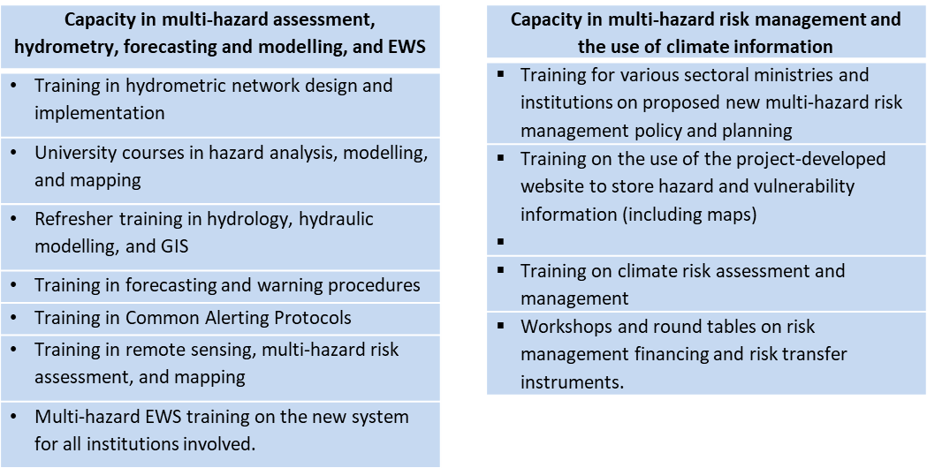

Tables 4, 5, 6 and 7 summarize skills availability, described on a qualitative scale of competence for some of the main institutions related to EWS deployment in the Gambia. The skills qualification are: No skills, meaning a user has no contact with geospatial knowledge; Basic, meaning a user can open and read maps in a GIS; Lower intermediate, meaning a user can create maps using vector and raster data and present them in a proper visualization; Upper intermediate, meaning a user understands basic theoretical concepts behind geospatial data, including GIS and remote sensing; High, meaning a user can perform relevant analyses in geospatial sciences; and Advanced, meaning users have had high-level formal training and relevant experience to work with GIS and remote sensing as well as train others on the methods and use of geospatial products. The institutions that have undergone this initial assessment include the Department of Water Resources (DWR); the National Disaster Management Authority (NDMA); the Meteorological division of the DWR (DWR-M) and the National Environment Agency (NEA).

Table 4. Geospatial skills profile for the DWR in understanding and using web-based EWS
Staff Category | # | Geospatial competence
Hydrologists | 3 | High (1); Basic (2)
Senior Technicians | 10 | Basic (4) No skills (6)
Support staff | 15 | No skills (15)

Table 5. Geospatial skills profile for the NDMA in understanding and using web-based EWS
Staff Category | # | Geospatial competence
GIS Technician | 5 | High (1); Basic (4)
Field Staff | 19 | No skills (19)

Table 6. Geospatial skills profile for the DWR-M in understanding and using web-based EWS
Staff Category | # | Geospatial competence
Meteorologist | 11 | Upper Intermediate (3); Basic (8)
Technicians | 42 | No skills (42)

Table 7. Geospatial skills profile for the NEA in understanding and using web-based EWS
Staff Category | # | Geospatial Competence
Program Assistants | 12 | Lower intermediate (3); Upper intermediate (1);  No Skills (7); High (1)
Program Officers | 6 | Lower Intermediate (1); Basic (1); No skills (4)
Senior Program Officers | 6 | No Skills (4); Basic (2)
Program Managers | 3 | No Skills (3)
Senior Program Assistants | 13 | No Skills (13)
Environment Inspectors | 13 | No Skills (13)
Senior Environment Inspectors | 7 | No Skills (7)

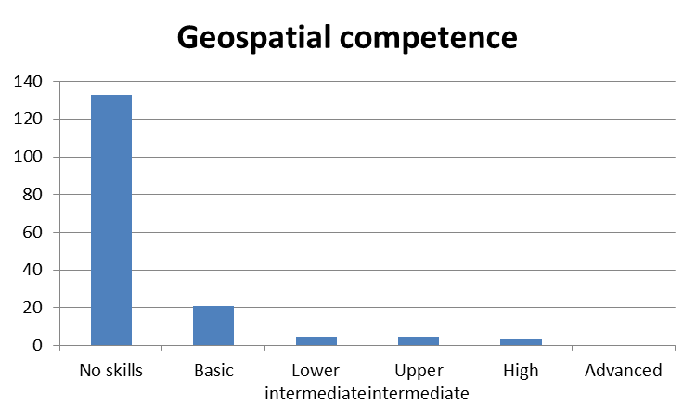

The assessments in Tables 4, 5, 6 and 7 show a substantial gap in geospatial competence among key institutions associated with EWS in the Gambia. This calls for serious considerations in the development of a well-thought-out training program to support the implementation of EWSs in the Gambia.

Table 8. User requirements for operating the GIS/data management system to be developed by the consortium
Thematic area | Required user skills | Desirable prior knowledge | Purposes
GIS software packages | Technical capabilities, etc. | Ex. Interpretation of spatial data, hazard risk identification and assessment | QGIS 3.20 https://qgis.org/en/site/  ArcGIS (10.6 and above) https://www.arcgis.com  Purpose  Understand the basic concepts of GIS and Remote Sensing in the context of Early Warning Systems
Web-based GIS | Understanding of how the internet works and how to use basic queries | Ability to work with a web-based GIS platform such as ArcGIS Online or QGIS Cloud | ArcGIS Online account  QGIS Cloud account  Purpose  The Early Warning System is going to be web-based, understanding how geospatial data works in web-based platforms is useful.
Data types  [Tablular] | Ex. data processing, data collection | Ex. Excel, Access | Building point datasets from a table of latitude/longitude coordinates.  Adding attribute data to a spatial data layer
Data types  [Polygon Point] | Ex. Rectifying spatial data and georeferencing spatial data layers  Creating shapefiles through digitization | GIS – geospatial data referencing and interpretation | Hydrogeology layers  ▪ Drinking water points; ▪ Well surveys  - Areal coverage of a water supply system  - Mapping groundwater contamination zones  - Groundwater monitoring network  Hydrometry  ▪ NRT river and stream gauge readings; ▪ Salinity readings  Disaster management  ▪ Flash flooding trouble spots  ▪ Fire risk (especially bush/forest fires)  Demographics  ▪ Buildings; ▪ Settlements  Climate data (station)  ▪ Precipitation; ▪ Temperature; ▪ Wind; ▪ Evapotranspiration  Infrastructure  ▪ Bridges, floodgates, surface water abstraction sites
Data types  [Polygon Polygon] | Ex. Rectifying spatial data and georeferencing spatial data layers, editing polygon data, attribute information, changing display and symbologies, adding new layers, etc. | Ex. geospatial data referencing and interpretation | Boundaries  ▪ Official administrative contours in GIS  Disaster management  ▪ Nationwide floodplain map
Data types  [Polygon Polyline] | Ex. Rectifying spatial data and georeferencing spatial data layers, editing polyline data, attribute information, changing display and symbologies, adding new layers, etc | Ex. Georeferencing spatial data, finding and adding new attribute information, etc. | Infrastructure  ▪ Roads  Hydrology  ▪ Hydrographic network in GIS format  Climate data  ▪ Sea level rise
Data types  [Raster] | Ex. Georectifying raster data, trimming raster data, data assimilation, spatial data interpolation, etc. | Ex. raster basics, e.g. resolution, scale, color coding, data types, spatial referencing raster data | Land use / land cover  ▪ Nationwide map of soil lithology with metadata and soil characteristics if possible  ▪ Nationwide vegetation cover map  ▪ Nationwide land use map  - Map of irrigation areas  Topography  ▪ High-resolution DEM  ▪ Drainage quality maps  Climate data (Gridded meteorological prediction data)  ▪ Total precipitation  ▪ Wind speed
Working with GIS data | Ex. user accounts and login (if applicable), versioning (if applicable), editing, adding layers, keeping track of metadata. | This will depend on the software used to build the GIS and store geospatial datasets | Ex. Keeping geospatial data up-to-date, especially for NRT analyses.
Working with GIS data | Identifying different types of risks from different types of geospatial data | Ex. Geology, hydrology or environmental science background, agricultural knowledge, knowledge of different types of geo- and climatic hazards common to the Gambia and the risks these tend to pose to which groups or economic sectors. | ▪ Identification of impending hazards and determination of hazard risks so that information can be disseminated to the right groups.  ▪ Mapping of hazard zone during emergency conditions, permitting a more comprehensive understanding of the geographical scale of disasters.  ▪ Real-time geographic data can improve the allocation of resources for response.  ▪ GIS technologies are much useful in the modeling of disaster risks and human adaptations to hazards.
Working with GIS data | Ex. Technical writing and communication skills, web development for updating online information in NRT | Ex. Web development (?) | ▪ Dissemination of information about impending geo- and climatic hazards to the right stakeholders.  ▪ GIS provides a decision support system in disaster management.  ▪ Thematic maps such as a hydro-geomorphologic maps, slope maps, terrain maps, and DEM generation in GIS. This is used for disaster planning.  ▪ Geospatial assessments are essential for management of rehabilitation and post-disaster reconstruction.
Empower municipalities to fulfil their mandate in using early warning systems for DRM |  |  | ▪ Clarify roles, responsibilities and accountability lines for use of the early warning system for DRM between the central government and municipalities  ▪ Train the ministry personnel and municipalities to integrate risk information in their planning and budget allocation decisions in key sectors, including training on use of risk information and mainstreaming tools and approaches  ▪ Link the use of early warning platform to integrate local DRM strategies with the local development plans (governorates / municipality plans); In the future, integrate the planning process for resilience building and the planning process for socio-economic development (instead of developing separate plans)  ▪ Document and disseminate best practices from the use of the early warning system and use to improve system design and use. Use network of municipalities to share best practices on DRM at local level.  ▪ Ensure that the national strategy for spatial planning and the national urban policy both integrate results of the early warning system for DRM and resilience building.

EM-DAT, the International Disaster Database. CRED/UCLouvain. https://public.emdat.be/
AfDB (2021) African Economic Outlook 2021 - From Debt Resolution to Growth, The Road Ahead for Africa. African Development Bank. Abidjan, Côte d’Ivoire.
Ibid AfDB (2021)
Ibid AfDB (2021)
The National Disaster Management Authority (NDMA) 2013. National Contingency Plan for the Gambia. Government of the Gambia, Banjul.
UNDRR (2019) Limitations and Challenges of Early Warning Systems - Palu-Donggala Tsunami Case Study. IOC Technical Series: IOC/2019/TS/150. Available here.
UN/ISDR Platform for the Promotion of Early Warning
Could also come in tabular format.
Could also be polygons depending on the zoom level or analysis unit
Could also be polygons depending on the zoom level or analysis unit

